**Library Management**

**Project for Modern Application 2, January 2024**

**SAJAL GARG**

**21f1000632@ds.study.iitm.ac.in**

Description: Library management is a multi-user application that allows users to request e-book which they want to read. It is a free platform with its unique set of features and capabilities. This application allows to read e-book for certain period of time and can it after they complete their read. The project at hand entails the development of a web-based Library management System application utilizing Python Flask as the backend framework and Vue.js as the frontend framework.

**Technologies Used**

**Backend**

● Python-flask, SQLAlchemy, flask-cors, flask-jwt-extended, celery, redis, smtplib

**Frontend**

● Vue 3, Vue-router, ApexCharts, Bootstrap

**Database Design**

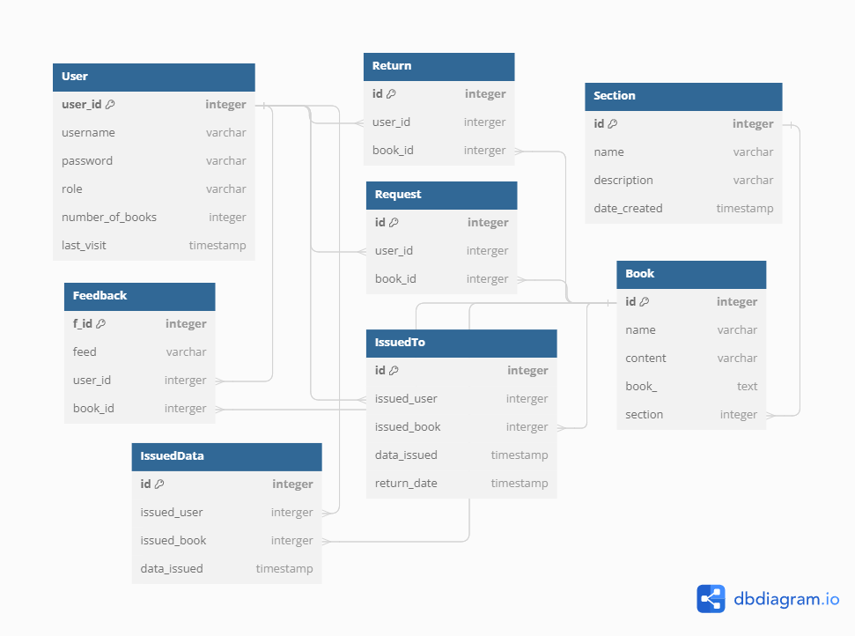

**Architecture and Features**

The library management app comprises two dashboard one for Admin and other for user. There is one Admin/Librarian who can perform functionality of add, edit and delete on book and section using APIs. User has his/her own dashboard which shows books and section the book they want to get issued. User can request admin for the e-book for certain period of time and admin can accept the request or decline as he/she wants. Last date is assigned to each issue of the book. User can get maximum of 5 books. User can give feedback about the book and search for particular book. The summary page graphically shows the number of Feedback given to each book.

**Asynchronous and Scheduled Jobs**

The app uses celery and Redis for asynchronous and scheduled jobs for daily mail and book expiry.

**PRESENTATION LINK**

https://drive.google.com/file/d/1id0shyElrT1H5SrXYMIIo5fxxBepX0DJ/view?usp=drive_link